- EFC picture. How would you examine the Bennett Hypothesis? That is, if federal aid increases, does affect the tuition students pay? How would you use this figure to identify this effect at the individual level?

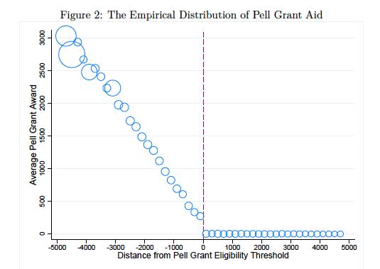

- Hydraulic Fracturing or “Fracking” became economically viable in the mid 2000s. This means that areas that had no oil reserves suddenly became viable for extracting oil. The question is how increased economic opportunity for men change marriage rates?
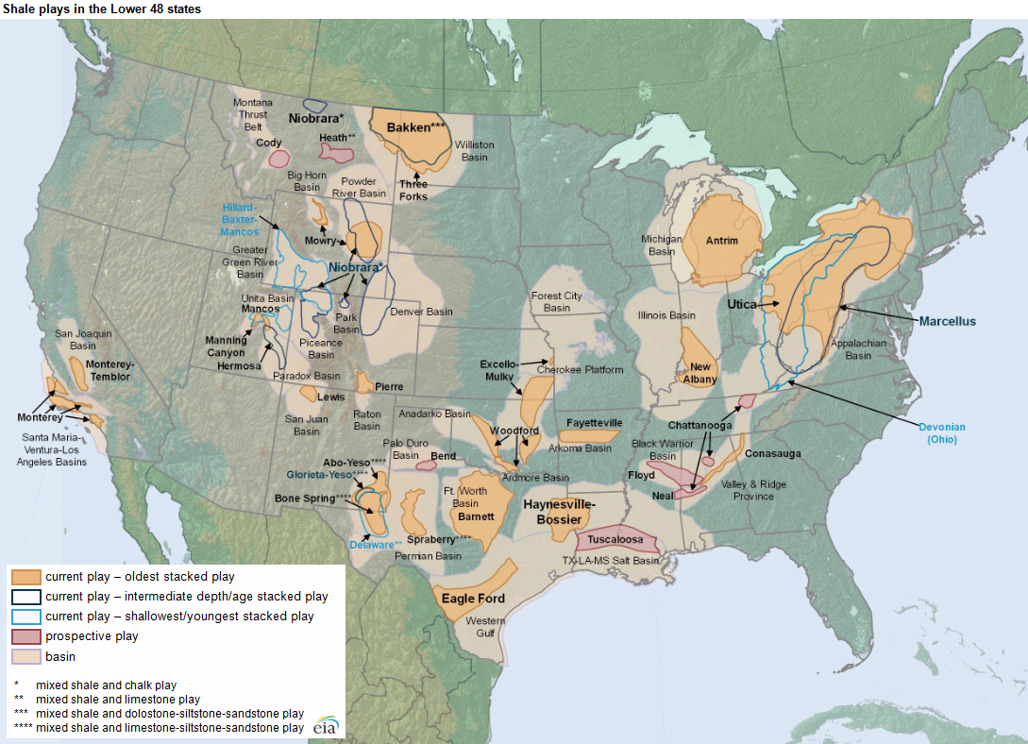

- A liberal arts college has a policy that all students must have laptops. Some classes require laptops, some classes ban laptops, and some classes have no policy. It is not random who requires and bans laptops. How would you estimate the effect of having a laptop on student success?
- If 40% of a college’s former students fail to repay their student loans, that institution is not able to disburse federal loans for the following years. What is the effect of offering federal loans on enrollment? (Darolia, 2013)
- Say you’re interested in knowing the labor market effects of having a for-profit degree. You have the capability to send many fake resumes to potential employers. How would you get at this? What do you actually estimate? (Deming et al. 2016)
- It used to be that in many states, people who wanted to be married had to submit to a blood test. In 1980, 34 states had blood testing laws. In 2006, only 3 states had these laws still on the books. If you wanted to estimate the effect of blood testing laws on marriage how would you do it? What would you need to assume? (Buckles Guldi Price 2011)
- Suppose you’re interested in the effect of MTO which gives vouchers for nicer housing. There are a lot of RCTs on this that basically find no effect. Now suppose you use the demolition of housing in a DD to look at the same outcomes. Which is preferred? Why? (Chyn 2018)
- Suppose that you’re interested in the effect of state business tax rates on the number of startups. You have information on the number of startups by county. State business tax rates are fixed over the time you have data but do vary across states. What could you do to get an estimate of the causal effect of state tax rates on start ups? (Curtis Decker 2018)
- In most places there are inservice days for teachers where school is let out. These occur on holidays and on some days that don’t appear to have any particular reason. How would you identify the effect of being out of school on teenage crime? (Jacob Lefgren 2003)
- Suppose you’re interested in the effect of a four day school week on crime. In Colorado, they allowed school districts to decide how to allocate the school days in 1980. By 2017, 98 operate on a four day schedule. How would you test for the effect of the four day school week on crime? What would you need to assume? (Argyle Fischer 2018)
- In 2009, an anonymous donor gave money to provide free Long Acting Reversible Contraceptives (e.g. IUDs) to low income women starting in 2009 in Colorado. (Lindo Packham 2019). You’re interested in the effect of access to LARCS on teen birth rates.
- In order to advance to the next grade in Chicago Public Schools you must pass an exam. How could you estimate the effect of grade retention on high school completion? What would you need to know? What would you identify? What assumptions would you need to make? (Jacob Lefgren 2009)
- Sweden implemented a carbon tax in 1991. You’re interested in the effect of the carbon tax on carbon emissions. (Andersson 2019)
- In 2009, The Obama administration suggested that states send out letters to people on unemployment insurance telling them that they were eligible for the Pell Grant. States did this at different times for different populations (see figure). What data would you need to see if this increased college attendance? What would your identification strategy be? (Barr Turner 2018)
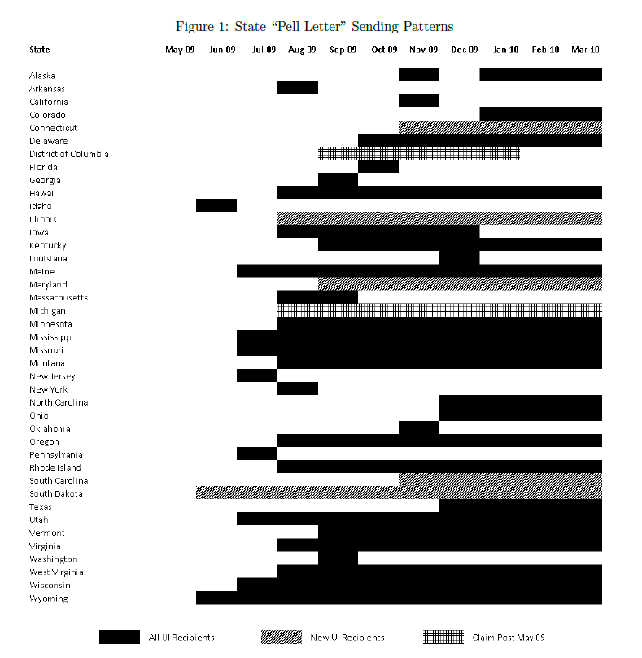
- Head start was rolled out in different counties at different times. What is the effect of head start on the children of women who attended?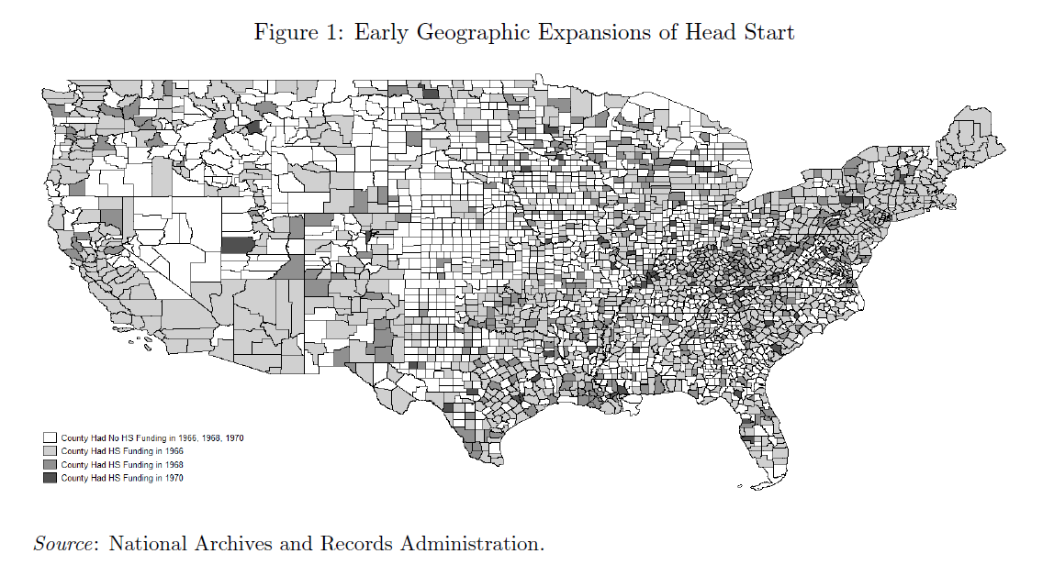
- In 2007-08 Indiana quadrupled funding for full day kindergarten. What is the effect on literacy? 5 districts in Indiana were over subscribed and assigned slots by lottery. (Gibbs 2014)
- What is the effect of Pre Trial detention on conviction? Judges can release defendants without bail or set bail. Judges spend 6 minutes with defendants. You have data on every judge in NYC from 2009-2013. Some judges are more lenient than others. It is not random when judges work, but conditional on the day/time of day it is random. How would you estimate this effect? (Leslie Pope 2017)
- When someone gets in a car crash, police officers are assigned to go investigate. How does this differ from a typical traffic stop? The question is how does having the police officer’s race match the driver’s race affect the probability of receiving a citation? What is identified? (West 2018)
- If your child is born before Jan 1, you receive several tax benefits for the entire year including EITC, child tax deductions, etc. If you are born just after, it takes a year to kick in. How does income during childhood affect earnings in adulthood? What assumptions should you worry about? (Barr Eggleston Smith 2021)
- The Soviet Union conducted nuclear testing in the 1950s and 60s. This got blown over to Norway due to weather patterns. How does nuclear fallout during childhood affect IQ at 18 years old? (Black et al 2019)

